4.3.5 IT Infrastructure
Audio Visual facility – LT3 - Image 1

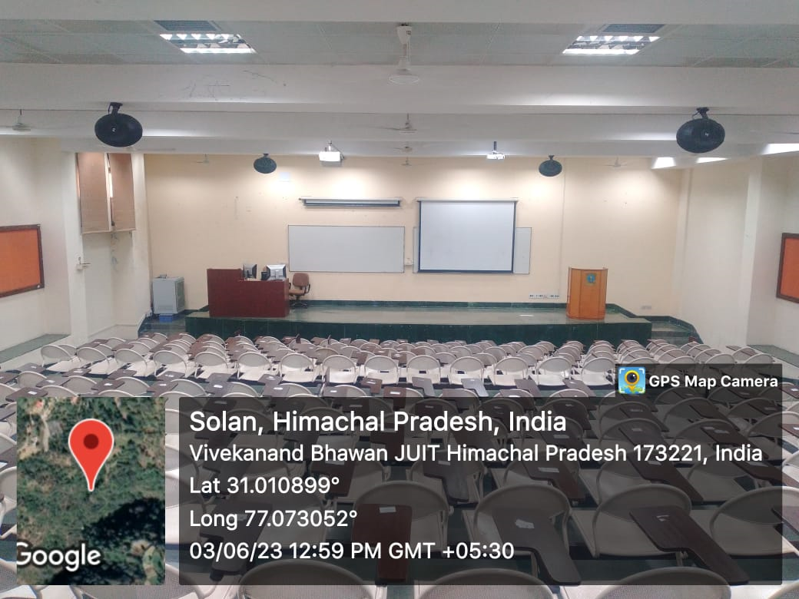

Audio Visual facility – LT3 - Image 2

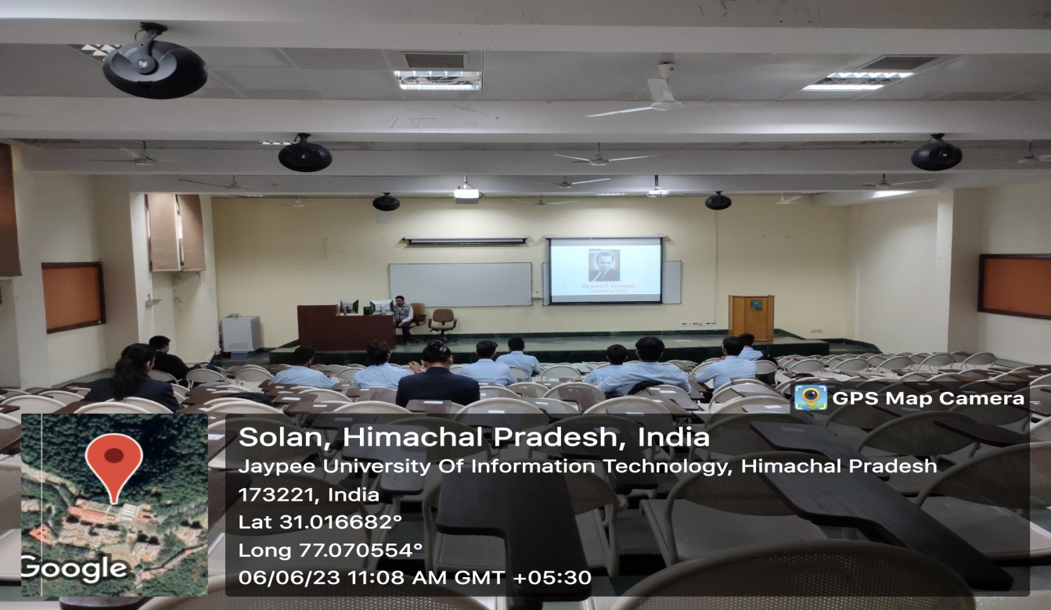

Lecture Capturing facility – Image 1

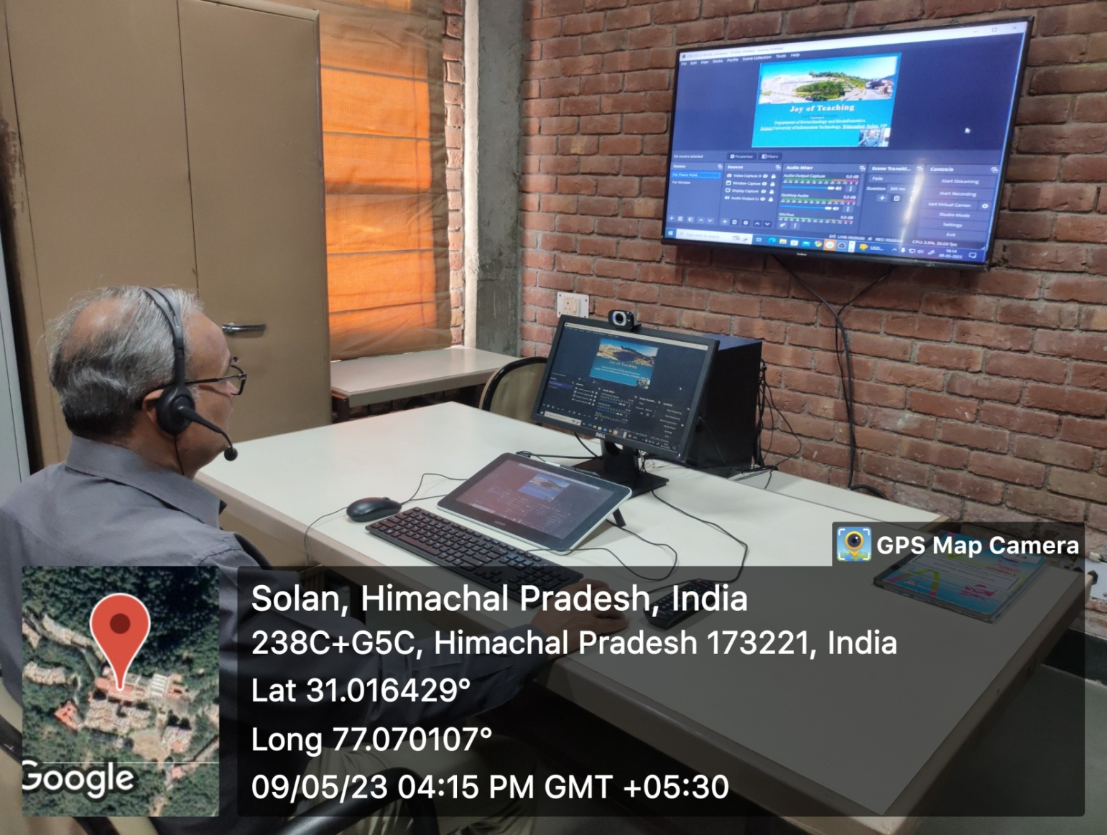

Lecture Capturing facility – Image 2

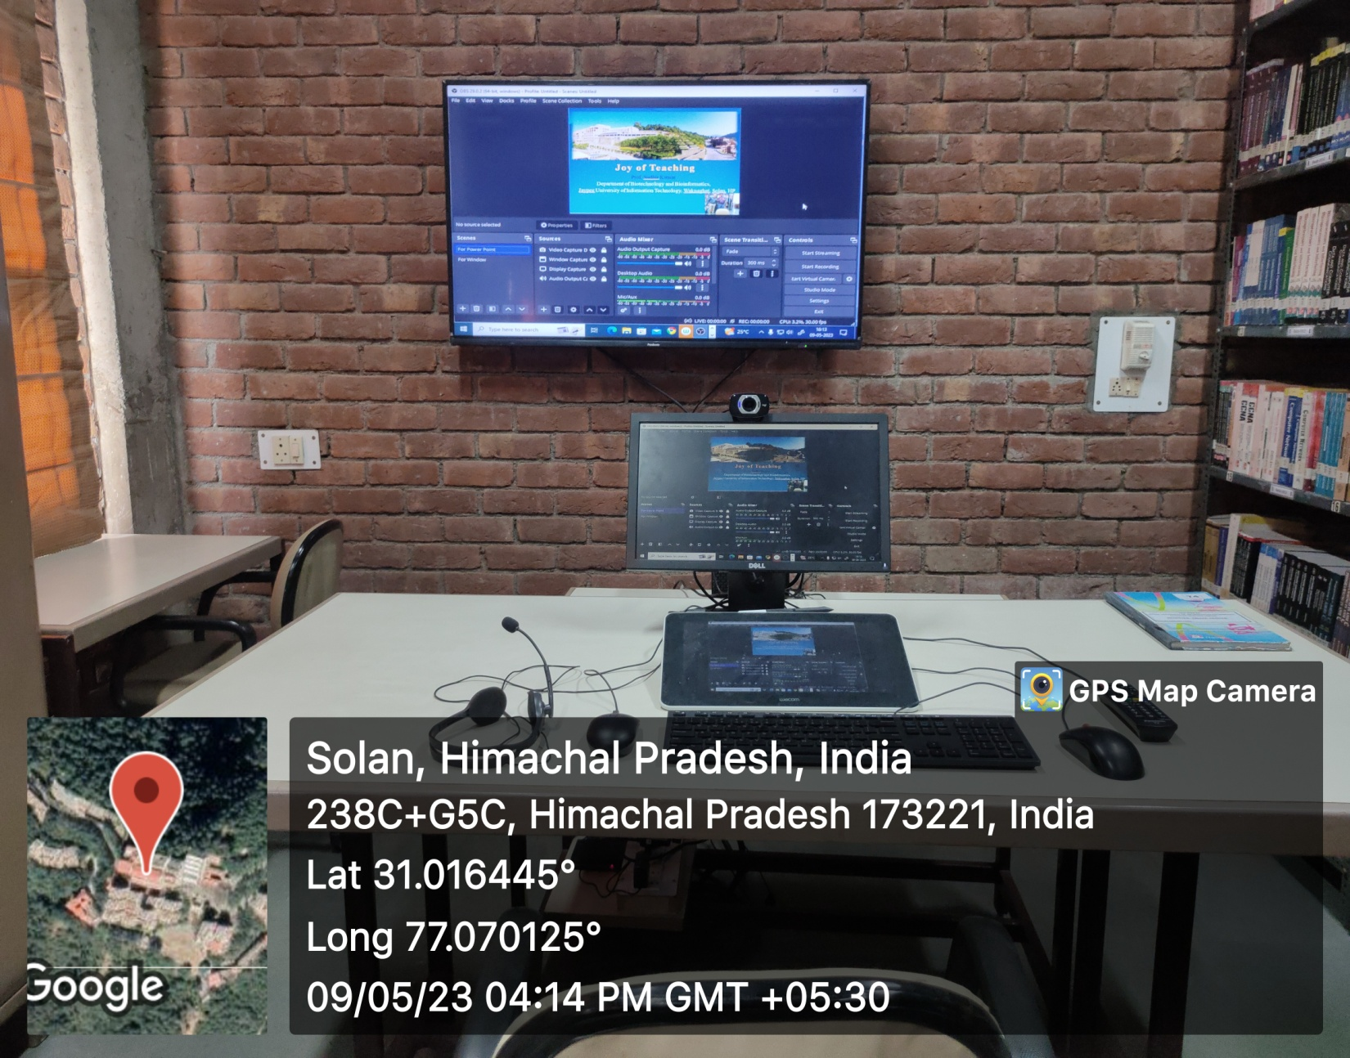

Software (OBS –Open Source Software) for Editing

